# smart #5 Debuts in Europe: Experience Next-Level Immersive Audio with the Sennheiser Signature Sound System

**Sennheiser's immersive in-car audio system is now available in the new smart #5 in Europe.**

***Wedemark, 22 March 2025* - Sennheiser, a leader in remarkable immersive in-car audio solutions developed by its mobility team, announces that its immersive in-car audio system is now available in the new smart #5 in Europe. The smart #5 is the brand’s first premium mid-size all-electric SUV and the most spacious and versatile smart to date.**

Sennheiser’s partnership with smart, which was announced in August 2024, is driving the future of in-car audio experiences. For unparalleled immersive audio, the new smart #5 is equipped with the Sennheiser Signature Sound System, featuring 20 high-performance speakers[1]. In combination with the lifting speaker on the dashboard, synchronized with ambient lighting, the audio system elevates every journey. ​

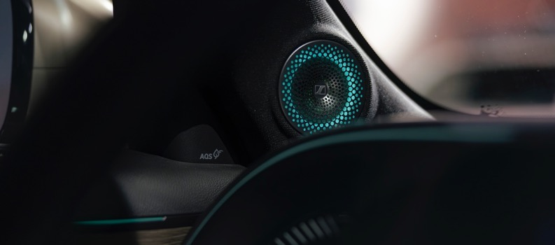

To ensure a personalized soundscape, users can fine-tune the audio to their preferences with a range of customization options, including three sound environment choices, Immersion Level, Bass Level, and Sound Focus Zones. With a maximum output of 1,190 Watts and onboard speakers designed and tuned by Sennheiser experts to support multiple audio formats, including Stereo and Dolby Atmos, the system delivers an adaptable and immersive listening environment on the road.

“We are delighted to deliver more products and experiences to Europe that create goosebumps in the automotive space through our partnership with smart,” says Veronique Larcher, Managing Director of Sennheiser Mobility. “Our remarkable Sennheiser signature sound system offers an exciting and customizable immersive listening experience that puts the driver and passengers at the centre of their favourite music.”

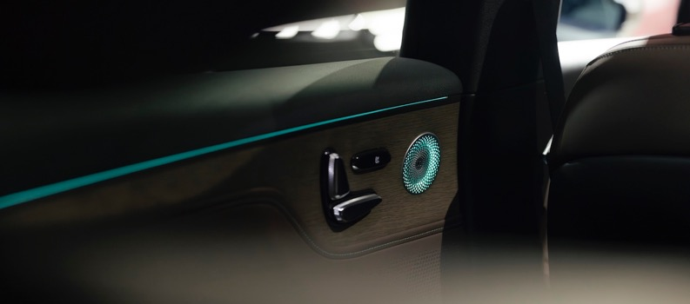

Sennheiser's sound philosophy is to preserve the artist's intention, and in the smart #5, the immersive system is tuned to spark emotions in the driver and passengers, perfectly aligning with the innovative and technologically advanced features present in the smart #5.

Dirk Adelmann, CEO smart Europe: "At smart, we are committed to redefine mobility by integrating cutting-edge technologies that enhance every aspect of the driving experience. Our partnership with Sennheiser perfectly embodies this philosophy. Together, we can offer our customers an unparalleled level of enjoyment as they explore the diverse roads in Europe in our all-new smart #5.”

The smart #5 will be available to order for customers starting April 24, 2025, in Germany, with rollouts across further European markets throughout the second and third quarters of 2025.

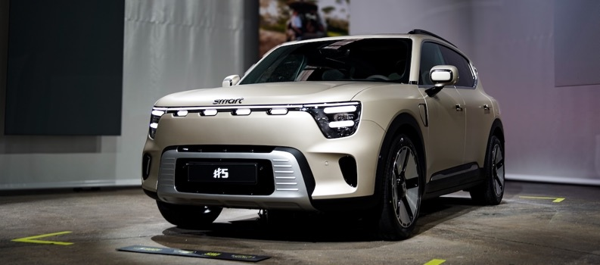

To learn more about the smart #5, visit [smart.com](http://www.smart.com/).

**About smart:**

smart Europe GmbH is a wholly-owned subsidiary of smart mobility International Pte. Ltd. and was founded in June 2020 in Leinfelden-Echterdingen, near Stuttgart. smart Europe’s international team is responsible for all sales, marketing and after-sales activities for the next generation of smart vehicles, products and services of the brand in the European market. With Dirk Adelmann as CEO and Martin Günther as CFO, the company is developing its full potential in Europe with a highly efficient and customer-oriented business model. The international smart joint venture was established between Mercedes-Benz AG and Geely Automobile Co., Ltd. smart positions itself as a leading provider of intelligent electric vehicles in the premium segment.

**About the Sennheiser brand**

We live and breathe audio. We are driven by the passion to create audio solutions that make a difference. Building the future of audio and bringing remarkable sound experiences to our customers – this is what the Sennheiser brand has represented for more than 75 years. While professional audio solutions such as microphones, meeting solutions, streaming technologies and monitoring systems are part of the business of Sennheiser electronic SE & Co. KG, the business with consumer devices such as headphones, soundbars and speech-enhanced hearables is operated by Sonova Holding AG under the license of Sennheiser.

[www.sennheiser.com](http://www.sennheiser.com)

[www.sennheiser-hearing.com](http://www.sennheiser-hearing.com)

**Sennheiser Mobility Press Contacts**

Felix Teufel

felix.teufel@sennheiser.com

Sarah Talaat

sarah.talaat@sennheiser.com

+49 152 22851987

1. Available in the Premium line.